**WordPress Blog**

The blogging feature which will enable the users to explore more types of hobbies and be able to create posts which other users can view them and also comment. This makes it an interactive way to keep the users engaged and increasing the user traffic to the website.

Use these instructions for setting up a local server environment for testing and development.

Installing WordPress locally is usually meant for the purpose of development. Those interested in development should follow the instructions below and download WordPress locally.

1. Install WordPress latest version from the website(<https://wordpress.org/>)
2. Install MAMP for mac

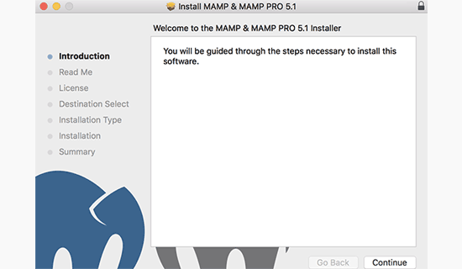

After the installation, you can go ahead and launch MAMP from the **Applications » MAMP** on your computer.

**Note:** MAMP also installs MAMP Pro (paid version), so remember to click on the right one.

Before you get started, we recommend configuring a few settings to make your MAMP experience better. You can do this by launching the Preferences menu and then switch to the ports tab.

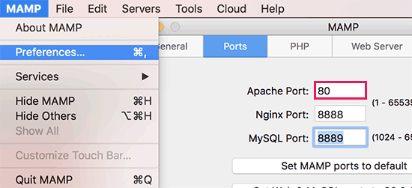

Enter port 80 for Apache and then click on the OK button.

Setting Apache to use port 80 will allow you to access your local websites from http://localhost instead of http://localhost:8888. However, this also means that each time you start MAMP servers, you will have to provide the admin password of your computer.

The next step is to set the document root folder. This will be the folder where you will create and store your websites. By default, MAMP uses /Applications/MAMP/htdocs/ folder, but you can change that to a more accessible location.

#### Installing WordPress on Mac

Now that you have set up MAMP, let’s go ahead and install WordPress on your Mac computer.

First you need to visit the [WordPress.org](http://wordpress.org/download/) website to download a copy of WordPress. After downloading the file, you need to unzip it.

Next, copy the wordpress folder inside and paste it into your MAMP document root folder. You can rename this folder to anything you want (example: mysite, wpbeginner, etc).

WordPress needs a [database](https://www.wpbeginner.com/glossary/database/) to store all website data, so you will need to create a database before we install WordPress. Don’t worry, it’s not as hard as it sounds.

Simply click on the **Open Web Start Page** button in MAMP application window. A new browser window will open where you need to click on **Tools » phpMyAdmin** from the top menu bar.

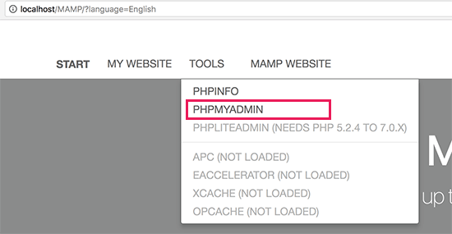

[phpMyAdmin](https://www.wpbeginner.com/beginners-guide/beginners-guide-to-wordpress-database-management-with-phpmyadmin/) is a web-based application used to manage MySQL databases. In phpMyAdmin, you need to click on Databases and then create a new database.

You can name this database anything you want, but please write it down because you’ll need the database name in the next step. For this tutorial, we will call it test_db.

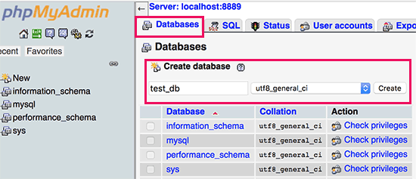

Now that you have created the database, it is time to install WordPress.

Go to http://localhost/mysite in a new browser tab. If you re-named the wordpress folder to something else, then use that name here.

You’ll now see the first step of WordPress installation wizard asking you to select a language.

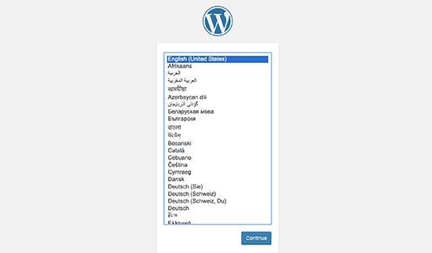

Select the language that you want to install WordPress and then click on the continue button.

On the next screen, WordPress will tell you about the information you will need to complete the installation. Click on the ‘Let’s go’ button to move forward.

Next, you will be asked to enter your WordPress database information. You already know the database name from the step earlier. For username and password, you need to use **root**. For the database host, you need to use **localhost**.

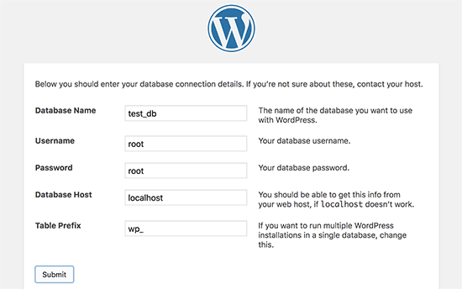

Once you are done, click on the submit button to continue.

WordPress will now connect to your database and create a configuration file for you. After this, it will show you a success message. Click on ‘Run the installation’ button to proceed.

On the next screen, WordPress will ask you to provide your website information, choose a username and password, and enter an email address. Go ahead and fill in the form and then click on Install WordPress button.

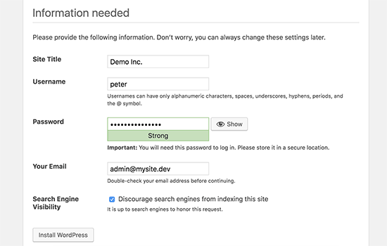

WordPress will now run the installation, and you’ll see a success message once it’s done.

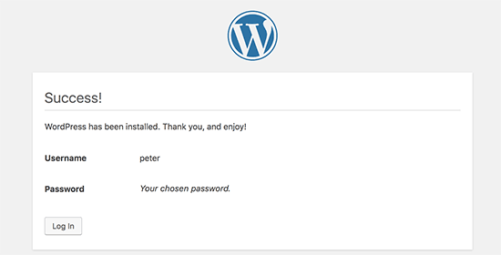

You can now go ahead and login to the WordPress site installed locally on your Mac computer.

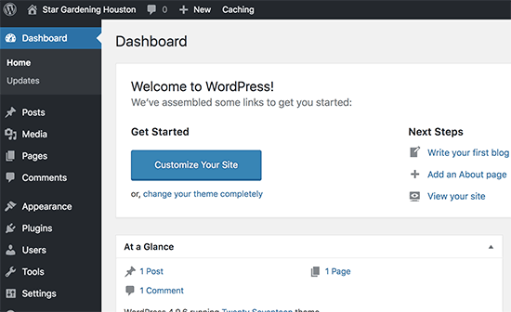

To Install plugins, we need to click on Plugins and search for the required plugin and install. Once it is installed, we need to activate the plugin.